My website will offer character creation and information services for Dungeons and Dragons. The site will be catered specifically to D&D players and dungeon masters. Users will need to register with the site. Using their account, they can create characters for both non-player characters and player characters alike. Besides character creation, the site will offer information lookup for anything practical in D&D (spells, equipment, weapons, status effects, classes, etc).

D&D’s site (https://www.dndbeyond.com) only offers base-game content and the creation of five characters. Making more than five characters, or viewing any content beyond the base game, is only available by purchasing a premium subscription and/or the additional content. My site’s goal is to offer a similar experience to that of *dndbeyond*, butwithout paywalls.

The API offers data on virtually all D&D content. The only data not provided by the API will be usernames and passwords provided by the user. Data stored locally from the API will consist of created characters, all information relating to that character, and the account a character belongs to. An early estimation of my database is on the following page.

The functionality of my site will not go beyond that of a CRUD application. Minor math will be needed to show users their character’s final statistics based on the traits chosen. Although the user will be able to query various information, the only information stored locally will be that in the ERD. The API chosen is well documented, but one issue I expect to encounter is organizing my data structures to pair well with the data received by the API. No API key is needed and no limit to requests has been made apparent.

Data stored by the site is relatively insensitive. Username passwords will be hashed, and users will not be able access another user’s character (without granted access). If time permits, users will be able to make their characters public and/or sharable to other users.

One expected, typical user flow is logging on and creating a character. If characters have already been made, the flow would be logging on, seeing created characters, and editing those characters or creating new ones. Character creation will either be one long screen or multiple forms across multiple screens.

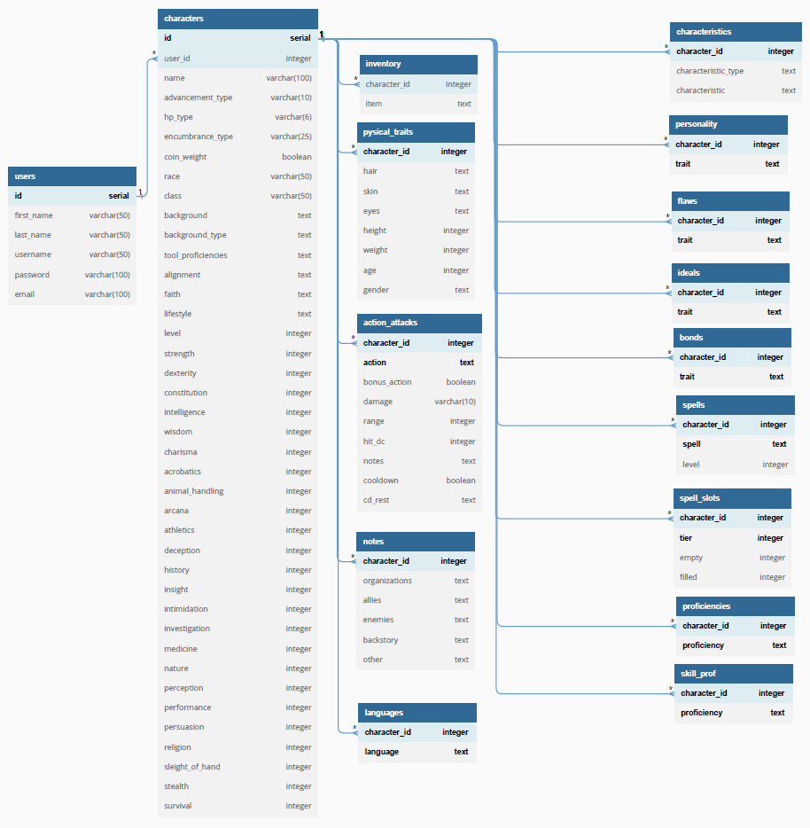API: https://www.dnd5eapi.co/